LS

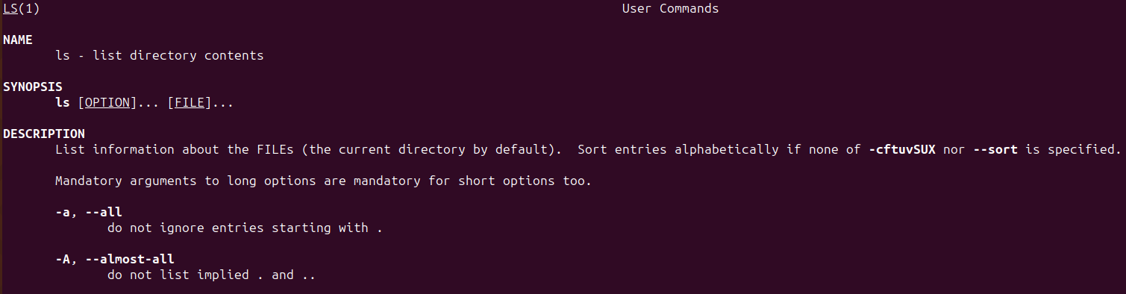
Man LS (manual)

Mkdir Palak (Make directory)
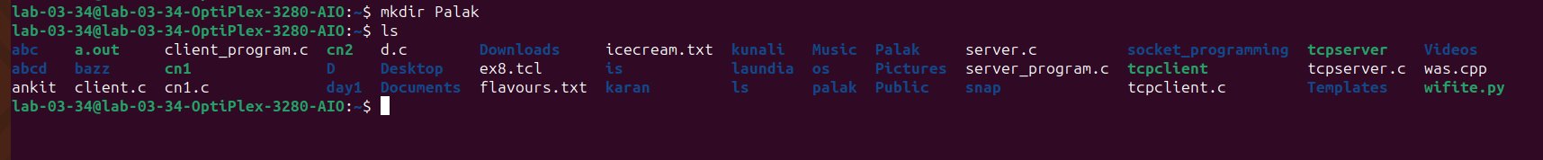

Rmdir (Remove directory)
ls -a
ls -A

